1. Logistic Prediction:

Below are the results for logistic regression:

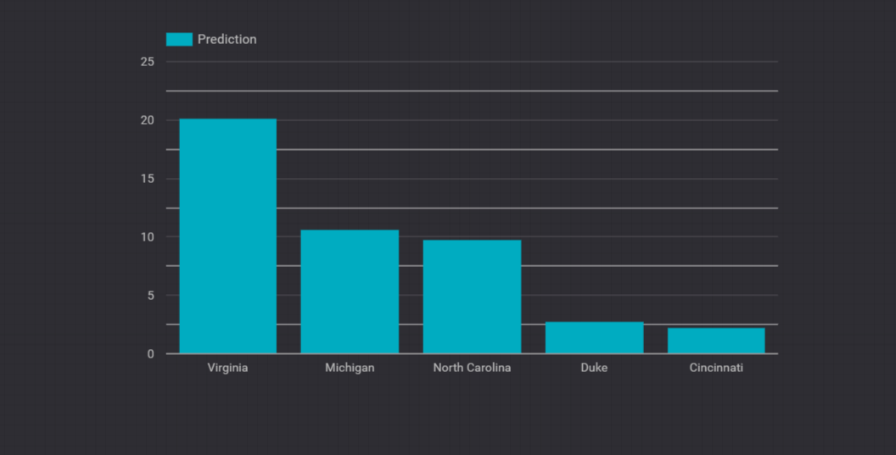

1. Neural Networks:

Our prediction model using Neural Networks gives the following results:

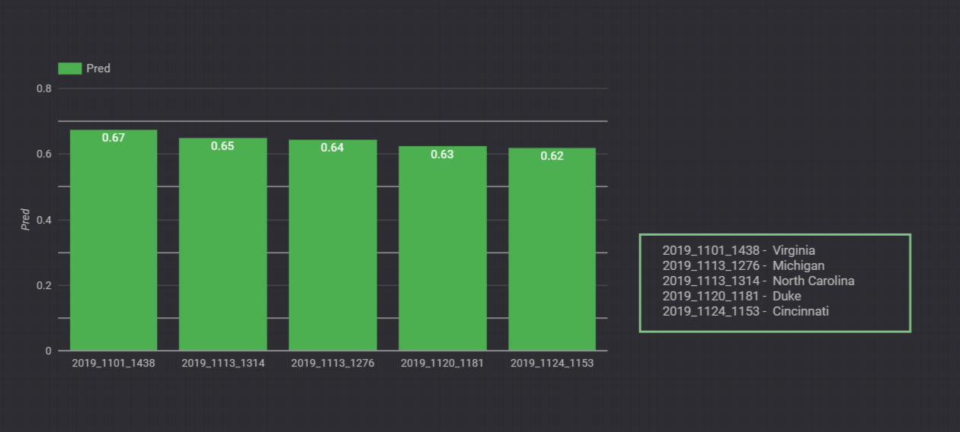

1. Feature extraction using Gradient boosting:

The following top 5 teams were predicted to be winning teams with Gradient boosting algorithm

